Assignment 1
Shital Digambar Bhadre
260740150022

Find the largest element in a list.
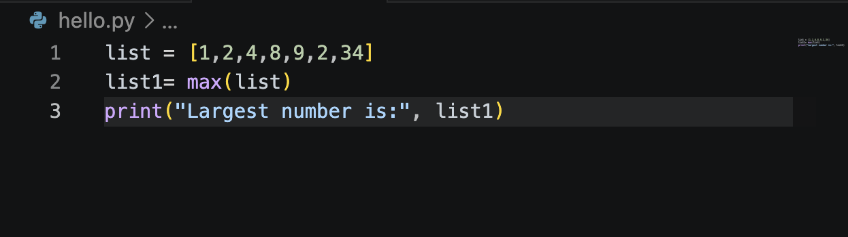

Output:
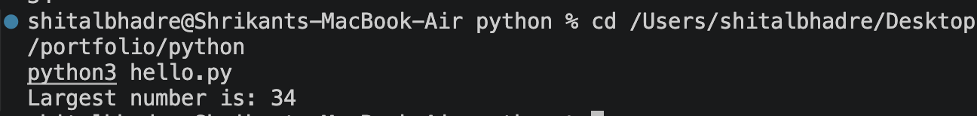

Find the smallest element in a list.
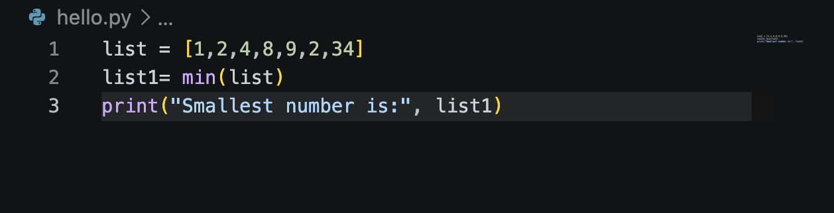

Output:
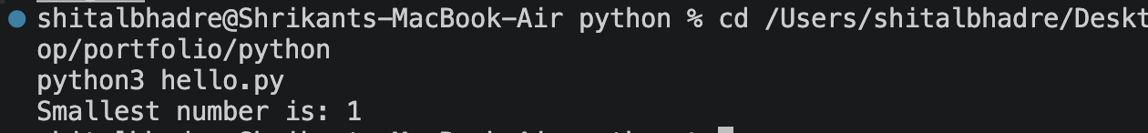
Remove duplicates from a list.
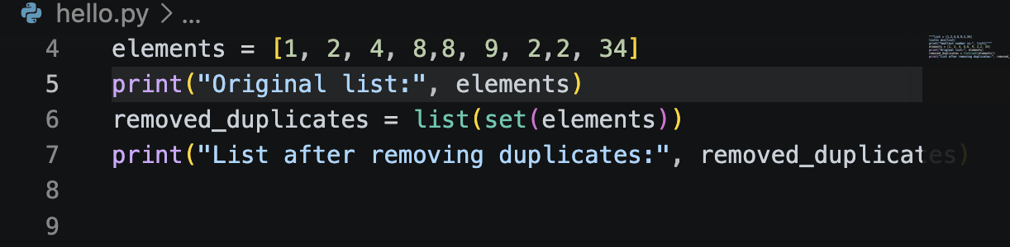

Output:
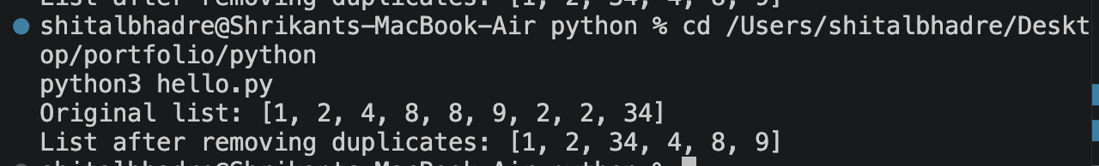
Reverse a list.
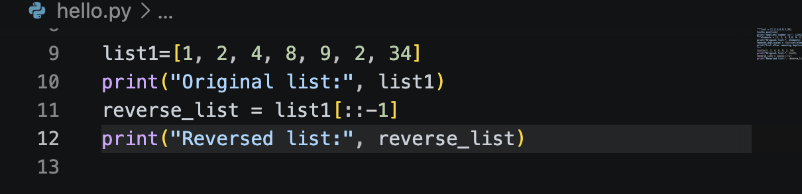

Output:
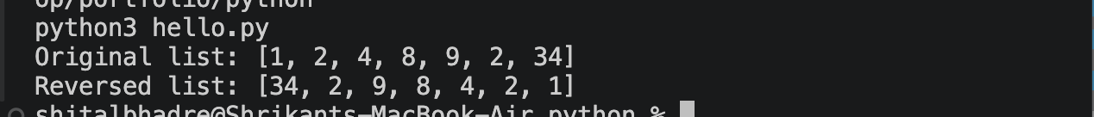
Find the sum of all elements in a list.
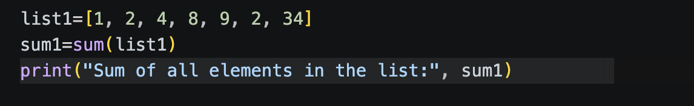

Output:
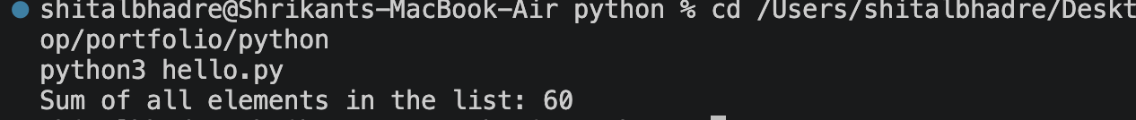
Find the second largest number in a list.
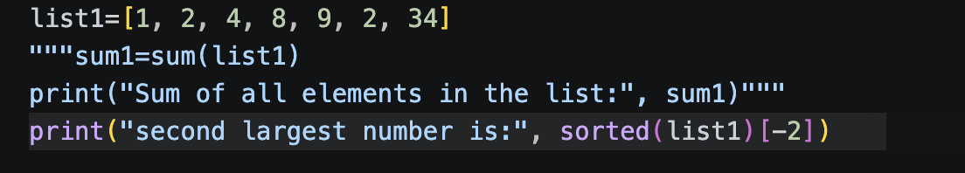

Output:
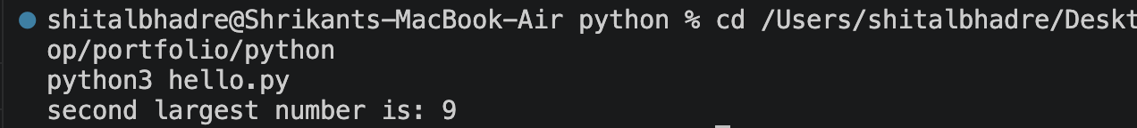
Count how many times an element appears in a list.
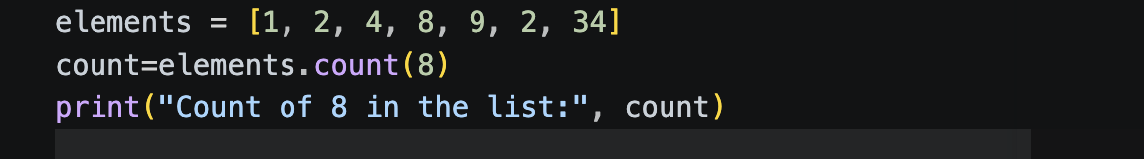
Output:
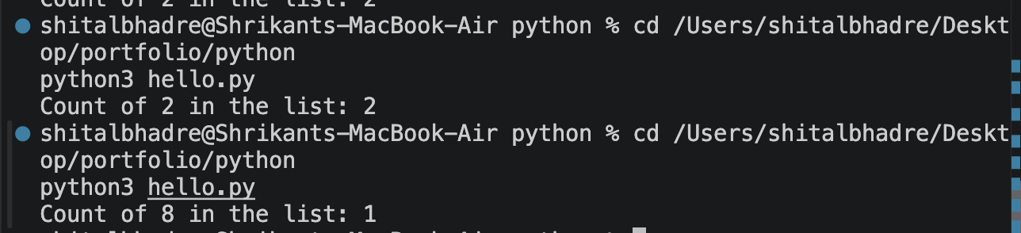

Merge two lists into one.
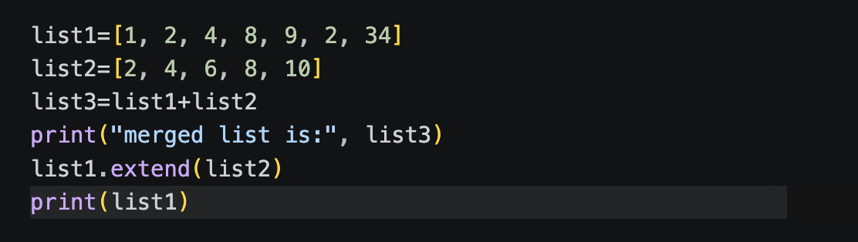

Output:
Sort a list in ascending and descending order.
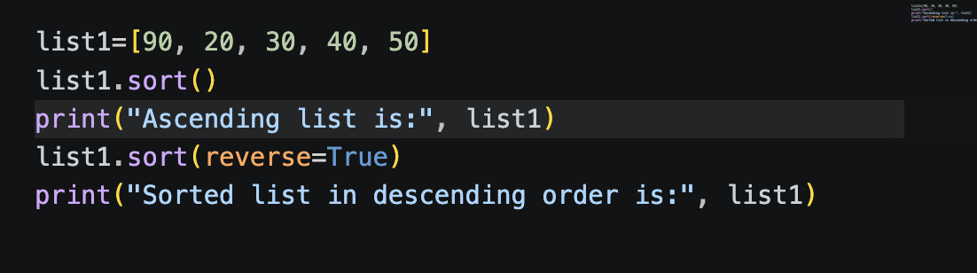
Output:
Create a new list with squares of all elements
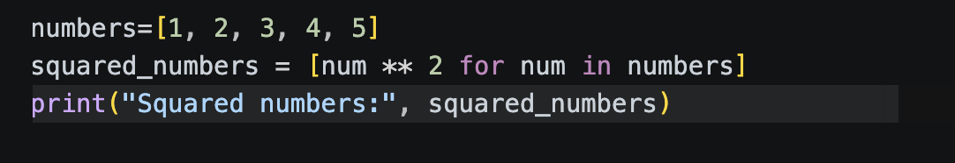

Output:

Assignment 2
Shital Digambar Bhadre
260740150022

Create a list of integers:
1. Find the sum of all elements
2. Find the maximum and minimum element
3. Sort the list in ascending order
numbers = [12, 45, 7, 23, 9, 34, 51, 18]
sum_of_numbers = sum(numbers)
max_value = max(numbers)
min_value = min(numbers)
sorted_numbers = sorted(numbers)
print("List:", numbers)
print("Sum:", sum_of_numbers)
print("Maximum:", max_value)
print("Minimum:", min_value)
print("Sorted ascending:", sorted_numbers)

output:
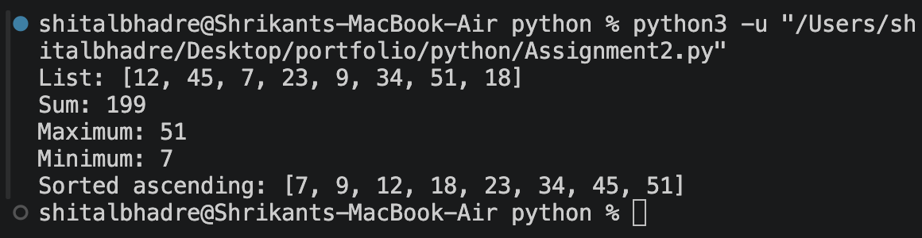
Write a program to remove duplicate elements from a list.
numbers = [1, 2, 2, 3, 4, 4, 5, 3, 6]

unique_numbers = []
for num in numbers:
if num not in unique_numbers:
unique_numbers.append(num)

print("Original list:", numbers)
print("List after removing duplicates:", unique_numbers)

output:

Create a tuple of numbers and:
1. Find the length
2. Find the largest and smallest value
Convert a tuple into a list and add a new element.

numbers = (10, 20, 30, 40, 50)
length = len(numbers)
largest = max(numbers)
smallest = min(numbers)
num_list = list(numbers)
num_list.append(60)
print("Tuple:", numbers)
print("Length:", length)
print("Largest value:", largest)
print("Smallest value:", smallest)
print("Tuple converted to list and new element added:", num_list)

ouput:
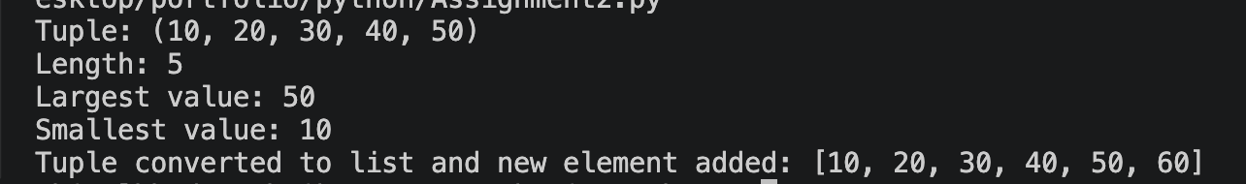
Write a program to:
1. Count vowels in a string
2. Reverse the string
Check whether a string is a palindrome.
text = "madam"
vowels = "aeiouAEIOU"
vowel_count = sum(1 for ch in text if ch in vowels)
reversed_text = text[::-1]
is_palindrome = text == reversed_text
print("String:", text)
print("Vowel count:", vowel_count)
print("Reversed string:", reversed_text)
print("Is palindrome?", is_palindrome)

output:
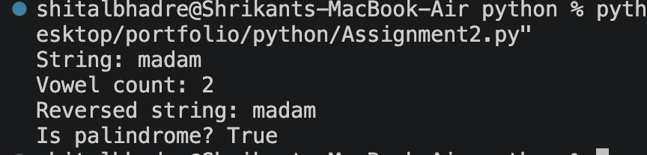

Create a dictionary of students and their marks. Display students scoring more than 75.
Add a new key-value pair and update an existing value.

students = { "Aditya": 82,
"Ram": 68,
"Myara": 91,
"Diana": 75,
"Era": 88,
"Filmona": 70
}

qualified_students = {name: marks for name, marks in students.items() if marks > 75}
print("Students scoring more than 75:")
print(qualified_students)

students["Grace"] = 94

students["Ram"] = 72

print("\nUpdated student marks:")
print(students)

output:
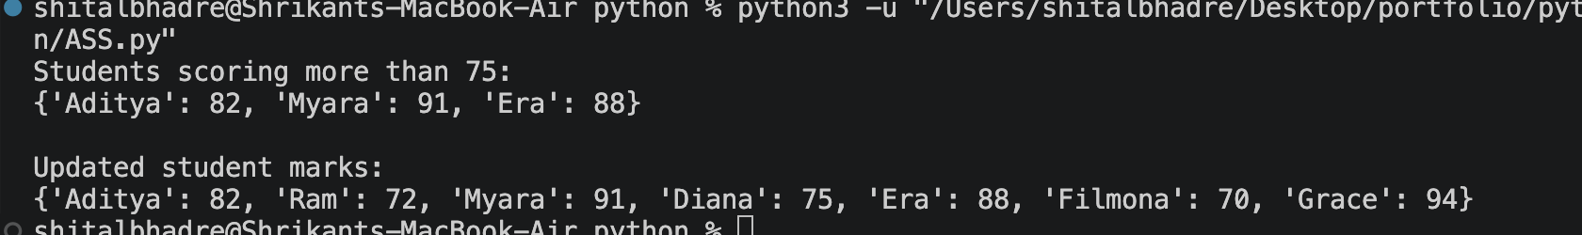

Create two sets and perform:
1. Union
2. Intersection
3. Difference

set1 = {1, 2, 3, 4, 5}
set2 = {3, 4, 5, 6, 7}
union_set = set1 | set2
intersection_set = set1 & set2
difference_set = set1 - set2
print("Set 1:", set1)
print("Set 2:", set2)
print("Union:", union_set)
print("Intersection:", intersection_set)
print("Difference (Set1 - Set2):", difference_set)

output:
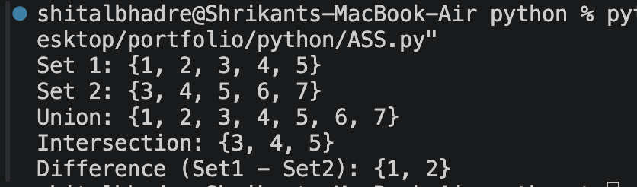

Write a program to remove common elements from two sets.
set1 = {1, 2, 3, 4, 5}
set2 = {3, 4, 5, 6, 7}
set1 = set1 - set2
set2 = set2 - set1

print("Set1 after removing comm elem:", set1)
print("Set2 after removing comm elem:", set2)

output:
Write a program to find the second largest element in a list.
list1 = [20, 23, 44, 12, 45, 90]
list1.sort()
second_largest = list1[-2]

print("List:", list1)
print("Second largest element:", second_largest)

output:
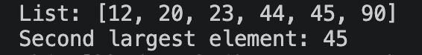

Write a program to split a list into even and odd numbers.
numbers = [12, 13, 24, 35, 46, 57, 68, 79]

even_numbers = []
odd_numbers = []

for num in numbers:
if num % 2 == 0:
even_numbers.append(num)
else:
odd_numbers.append(num)

print("Original list:", numbers)
print("Even numbers:", even_numbers)
print("Odd numbers:", odd_numbers)

output:
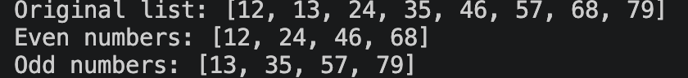

Write a program to merge two lists without duplicates.
list1 = [1, 2, 3, 4, 5]
list2 = [3, 4, 5, 6, 7]
merged_list = list1 + list2
result = []
for item in merged_list:
if item not in result:
result.append(item)
print("List 1:", list1)
print("List 2:", list2)
print("Merged list without duplicates:", result)

output:
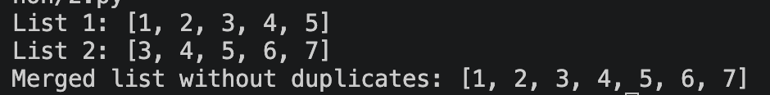

Find the index of an element in a tuple.
numbers = (10, 20, 30, 40, 50)
search_value = 30

index = numbers.index(search_value)

print("Tuple:", numbers)
print("Element to find:", search_value)
print("Index of the element:", index)

output:
